SQL/XML

What the standard says

What officially should be there for SQL product with XML functionality

Look at the specific dialects or limitations in the next 2 lectures.

SQL/XML -add some support for XML in relational databases

SQL/XML – part of the SQL standard.

Started with SQL:2003 standard.

SQL 92:1992 standard

86 one ,92 then 99

SQL:2006 improved it

Our products – in between all the versions ,they don’t support everything.

They may support something all the way from 2011.

What does SQL/XML add to the standard and language of relational databases?

Data type

Want to have specific data type for XML.

Formally have a data type for XML that is supposed to be more correct in the implementation internally.

Have to be able to compose XML – construct XML as output of select statement.HHa

To go from relational data to XML, and we also have the other way around.

We need to be able to run Xquery from within SQL.

Take different nodes, put them in tables.

Split one XML into 500 tables and hundreds of rows.

Until 2008 only Xquery – for,let,where,return.

How to interact between a column and an Xquery

How to execute Xquery,send things from one context to the other.

XML data type – Supposed to be formal data type that uses

Xquery model or Xpath to model with the nodes.

Node tree

Each node has type,value,parent.

Before this standard.

We can query the data because it will have correct representation.

Standard allows data type to support fragments or documents.

We can evolve it to next level.

Can add XML schema and DTD.

FOREST – Many elements

XMLPARSE – string to XML or XML to string.

* - 0 or more employment.

Either Employments that are ongoing or employments that have finished.

XMLELEMENT – create an XML element node.

Specify element’s name after keyword NAME

Specify element’s content.

One column with 8 XML elements

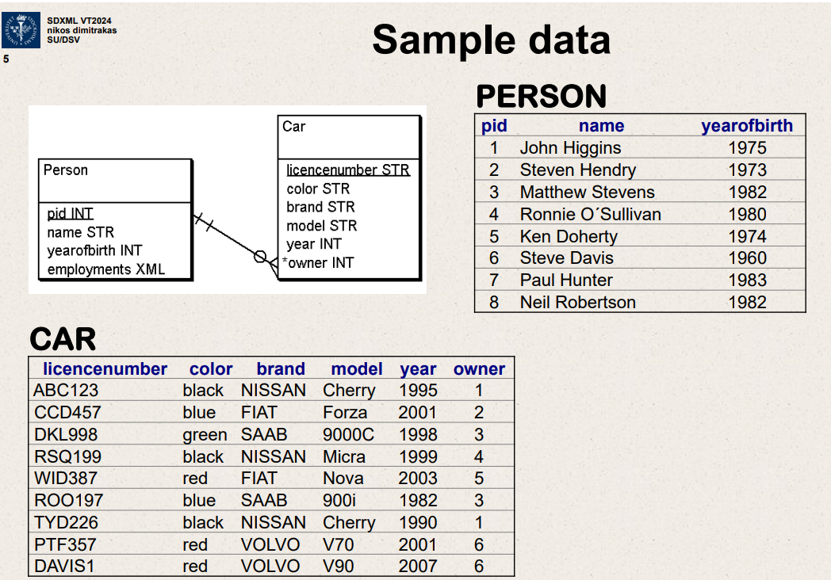

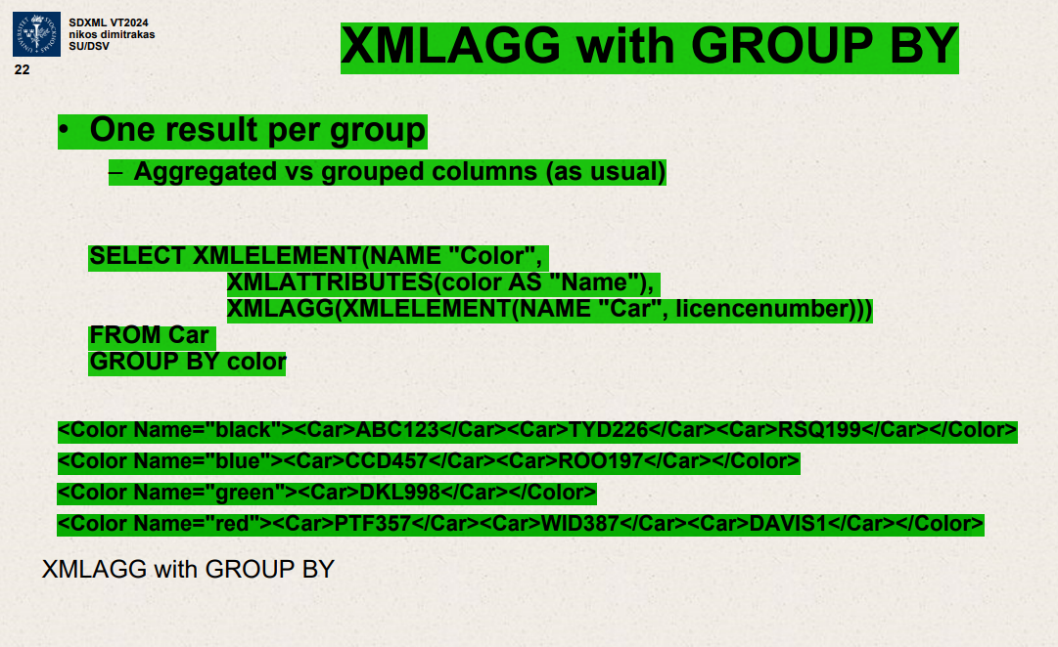

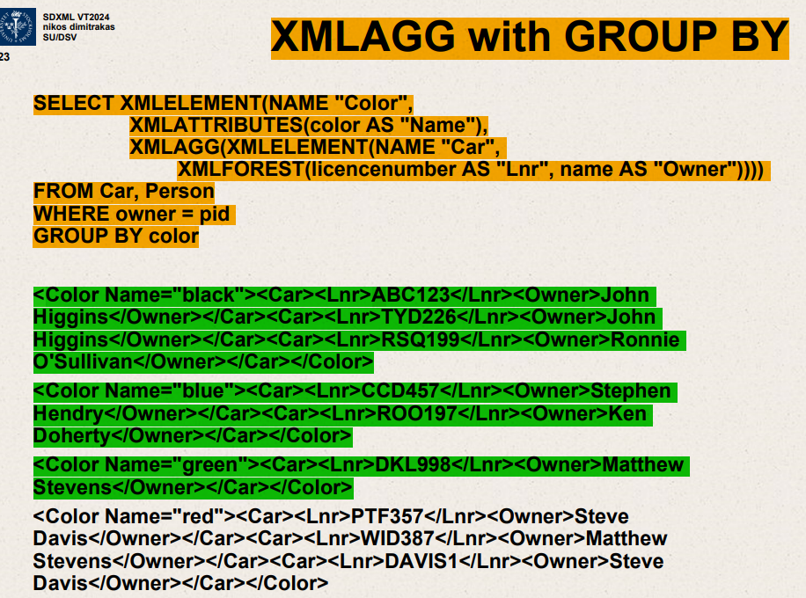

XMLAGG with GROUP BY

2 tables we have to join them.

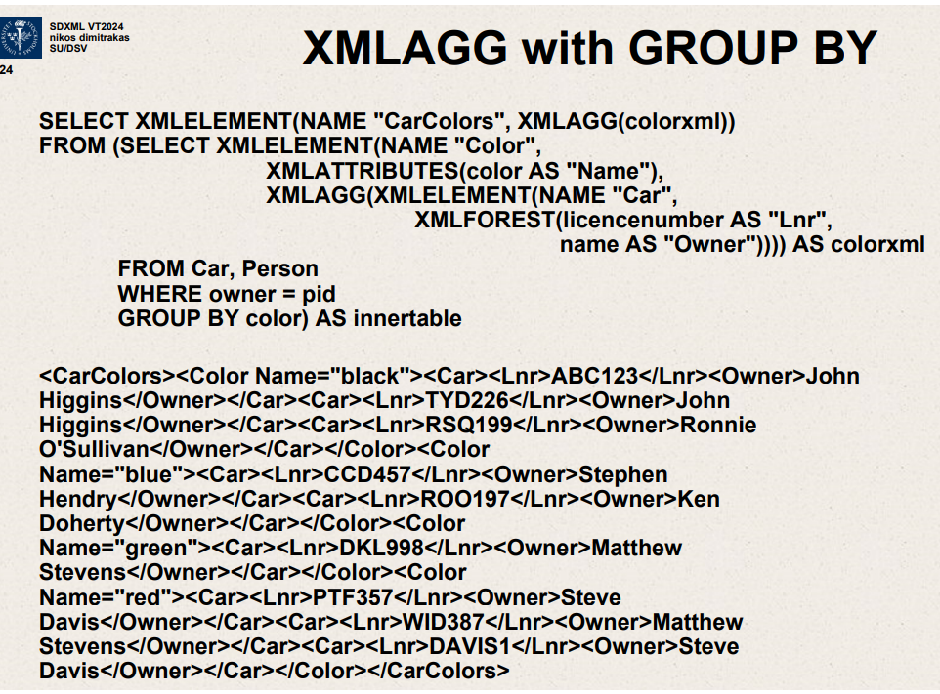

SELECT XMLELEMENT (NAME “CarColors”,XMLAGG(colorxml))

The image you've uploaded appears to contain text explaining an SQL query that uses Oracle’s XML functions to aggregate data and produce XML output. The text describes a method for creating nested XML elements by using a combination of SQL functions like **XMLELEMENT**, **XMLATTRIBUTES**, **XMLFOREST**, and **XMLAGG** along with **GROUP BY**.

Here's a breakdown of the concepts and SQL functions shown in the image:

1. **XMLELEMENT**: This function creates an XML element with a specified name. For example, **XMLELEMENT(NAME "Car")** creates an XML element **<Car>**.
2. **XMLATTRIBUTES**: It's used to define attributes for an XML element. The attributes are specified as a comma-separated list. For instance, **XMLATTRIBUTES(color AS "Name")** creates an attribute **Name** with its value set from the **color** column in the result set.
3. **XMLFOREST**: This function is used to create a series of XML elements from columns. Each column becomes an XML element, and if an alias is provided, it becomes the name of the element. For example, **XMLFOREST(licencenumber AS "Lnr", name AS "Owner")** would create XML elements **<Lnr>** and **<Owner>** with values from **licencenumber** and **name** columns, respectively.
4. **XMLAGG**: This function aggregates multiple XML elements into a single XML fragment. It's often used in conjunction with **GROUP BY** to aggregate rows of data into a nested XML structure based on a common key.
5. **GROUP BY**: A SQL statement that is used to group rows that have the same values in specified columns into summary rows, like "find the number of customers in each country".

The SQL query in the image is constructing an XML document with the following structure:

* The root element is **<CarColors>**.
* For each group of cars (grouped by their color), it creates a **<Color>** element with an attribute **Name** set to the color of the cars.
* Inside each **<Color>** element, it uses **XMLAGG** to aggregate **<Car>** elements, each containing:
  + A **<Lnr>** element, representing the license number of the car.
  + An **<Owner>** element, representing the owner of the car.

This results in an XML document where cars are grouped by color, and within each color, you have a list of cars and their owners. The SQL assumes that the **Car** and **Person** tables have been joined on the owner's ID (**owner = pid**) and then grouped by the **color** column.

The actual SQL code is truncated in the image, but based on the visible part and the resulting XML, the structure is intended to facilitate easy retrieval of cars by their color and related owners' information in an XML format.

Top of Form

XMLCOMMENT  
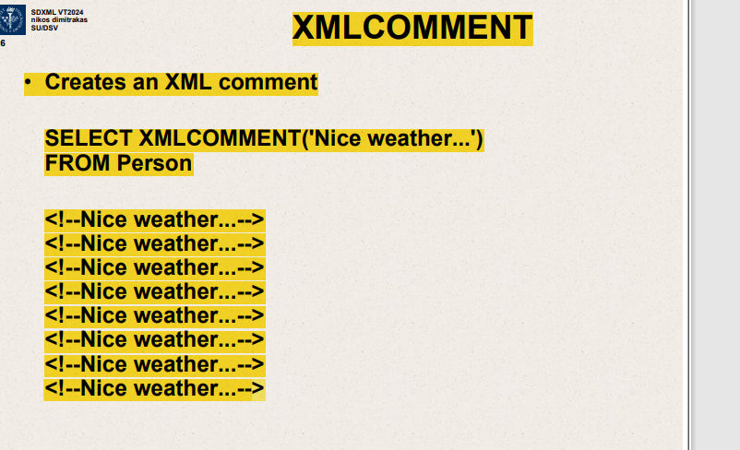

8 identical comments

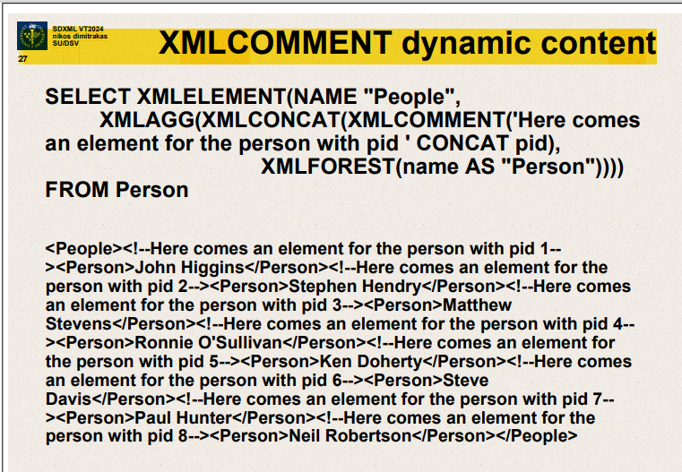

SELECT XMLELEMENT (NAME “People”,

XMLAGG(XMLCONCAT(XMLCOMMENT

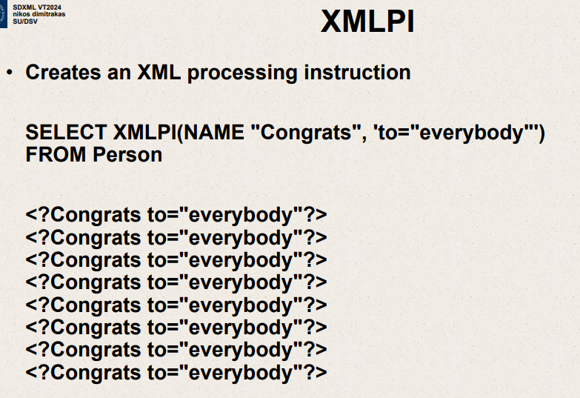

XMLPI – creates XML processing instruction

SELECT XMLPI (NAME “Congrats” ,’to=”everybody”)

FROM Person

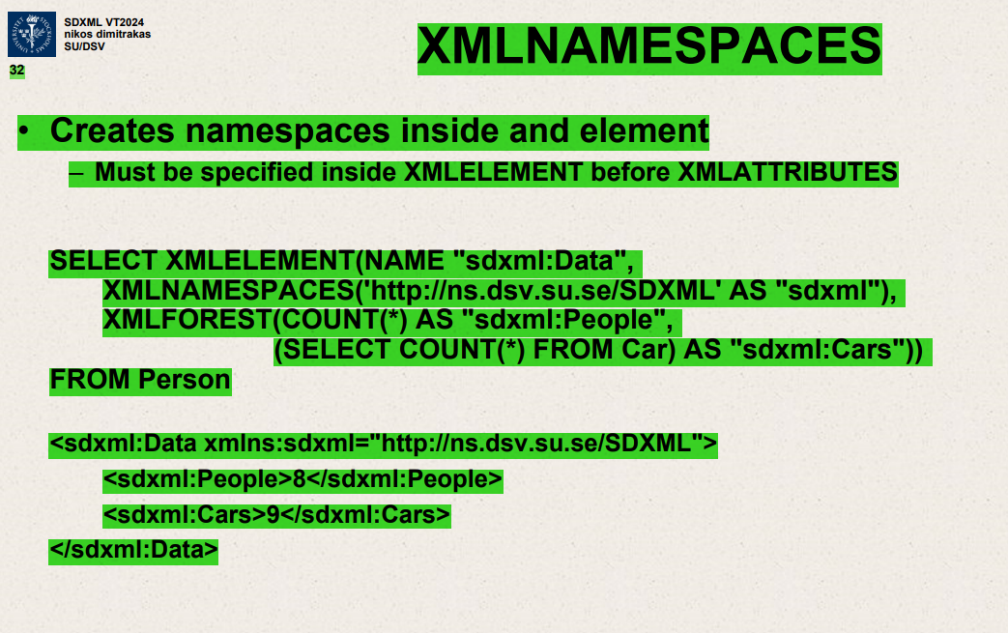

XML NAMESPACES

Creates namespaces inside an element.

Must be specified inside XMLELEMENT before XMLATTRIBUTES

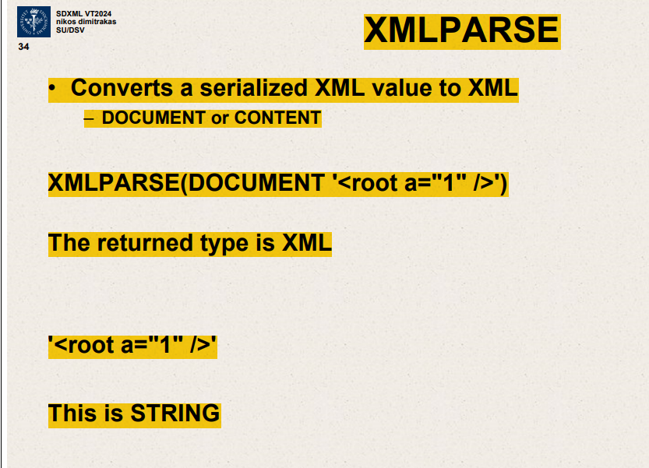

Converts a serialized XML value to XML.

DOCUMENT or CONTENT

Parse a string and convert to XML datatype.

XMLPARSE (DOCUMENT ‘<root a=”1”/>’)

Return type is XML.

‘<root a=”1”/>’ – this is STRING.

Send it as string it will convert to XML datatype.

XMLSERIALIZE – Take something that is XML, convert it back to a string.

XMLSERIALIZE ( xmlvalue as CLOB)

XMLCAST – converts values from and to XML.

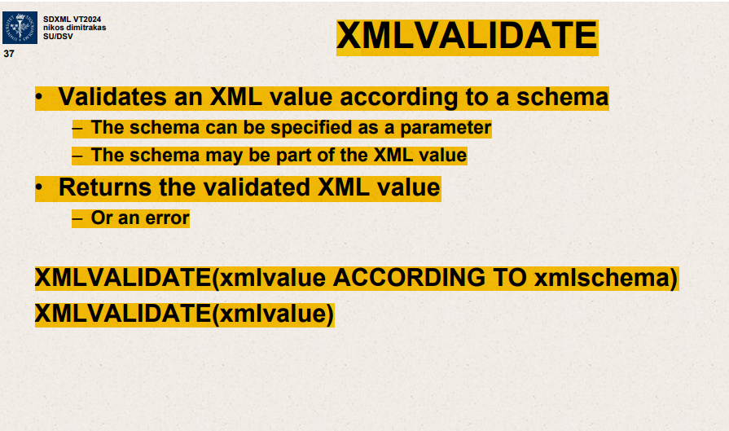

XMLVALIDATE - Validates an XML value according to a schema.

Schema specified as a parameter.

Schema may be part of XML value.

Returns validated XML value

Or an error.

XMLVALIDATE(xmlvalue ACCORDING TO xmlschema)

XMLVALIDATE(xmlvalue)

XMLQUERY – Executes an Xquery statement.

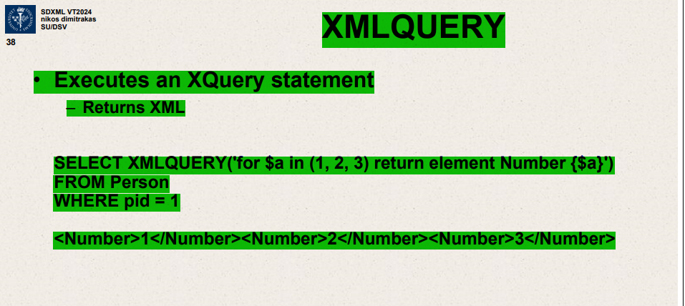

Executes an Xquery statement

Returns XML

Can put XMLQUERY in SELECT

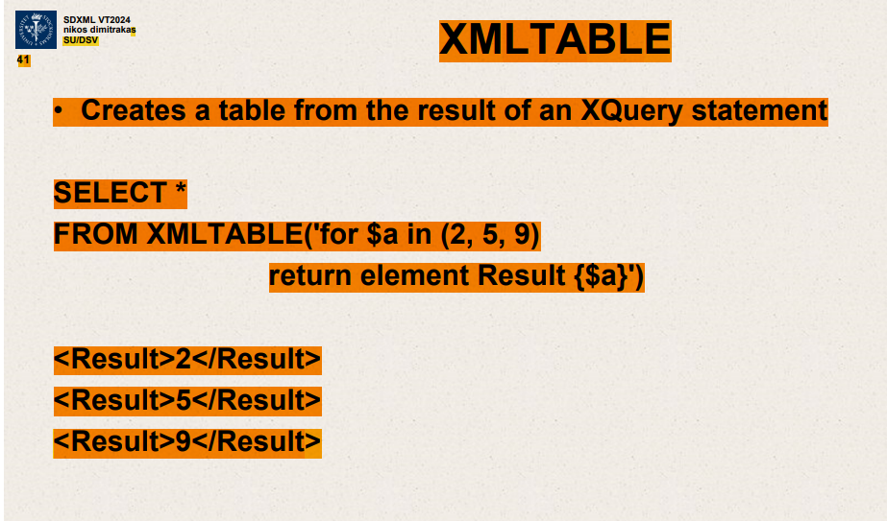

Can put XMLTABLE only in FROM

SELECT *

FROM XMLTABLE(‘for $a in (2,5,9)

Return element Result{$a} )

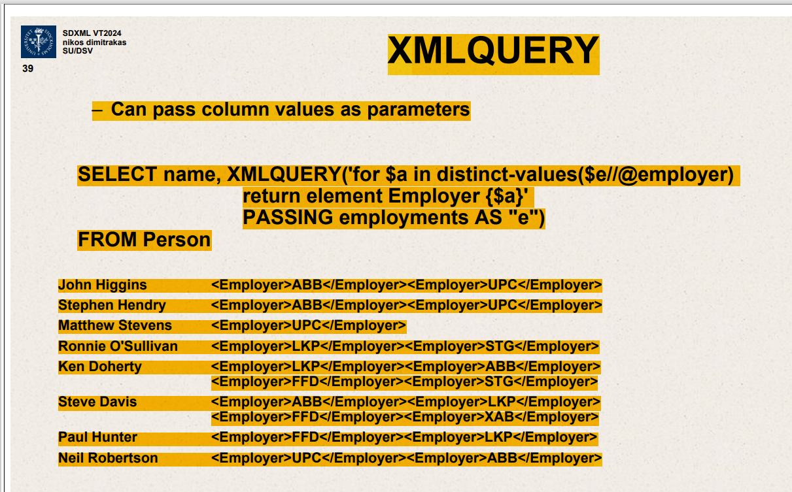

SELECTs name ,XMLQUERY (‘for $a in distinct-values($e//@employer)

Return element Employer{$a}’

PASSING employments as “e”)

FROM Person

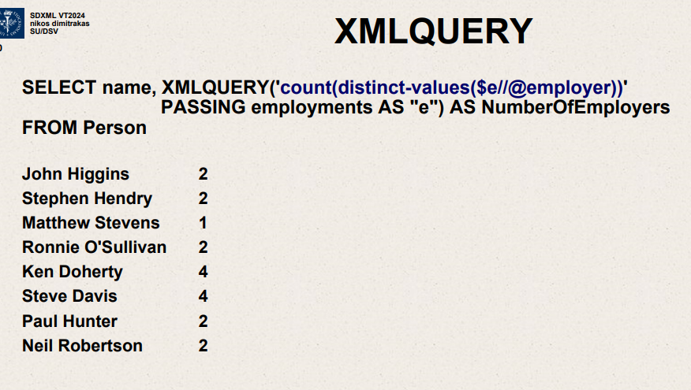

SELECT name, XMLQUERY(‘count(distinct-values($e//@employer))’

PASSING employments as “e”) AS NumberOfEmployers

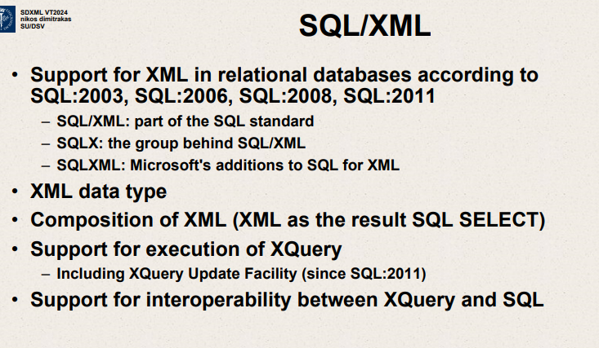

Support for XML in relational databases according to SQL:2003, SQL:2006,SQL:2008, SQL:2011

SQL/XML – part of SQL standard

SQLX – group behind SQL/XML

SQLXML – Microsoft addition to SQL for XML

XML data type

Composition of XML (XML as result of SQL select)

Support for execution of Xquery – Including Xquery Update Facility

Support for interoperability between Xquery and SQL

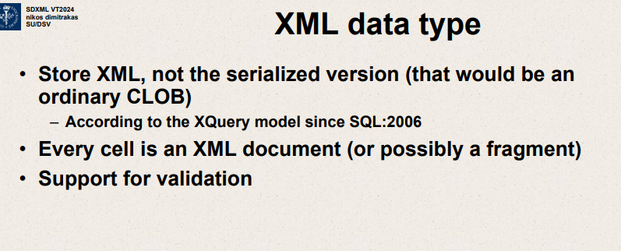

Store XML, not serialized version

Every cell is XML document (or possibly a fragment)

Support for validation

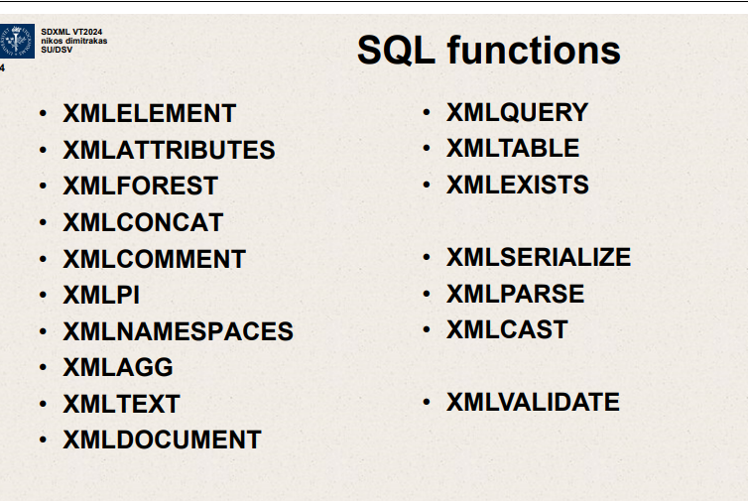

XMLELEMENT XMLCOMMENT  
XMLATTRIBUTES XMLPI  
XMLFOREST XMLNAMESPACESZ  
XMLCONCAT

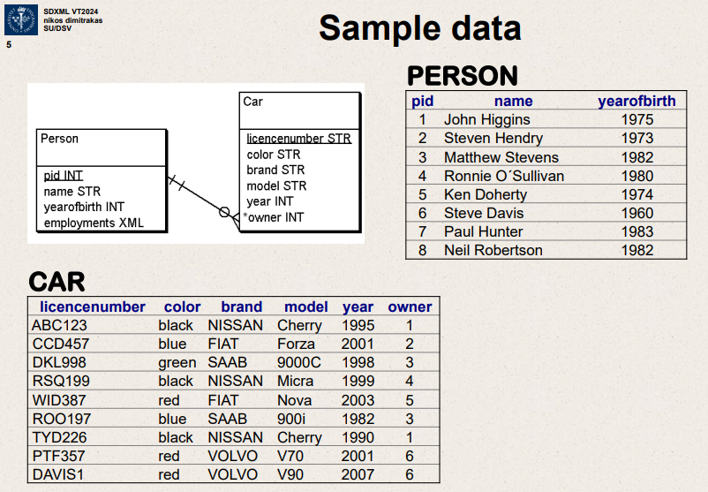

Sample data

PERSON

Person Car

CAR – licensenumber,color,brand,model,year,owner

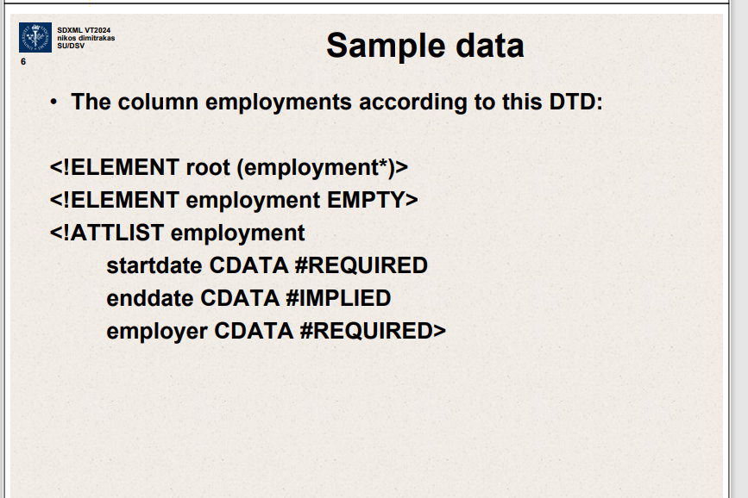

Column employments according to this DTD  
<!ELEMENT root (employment*)>

<!ELEMENT employment EMPTY>

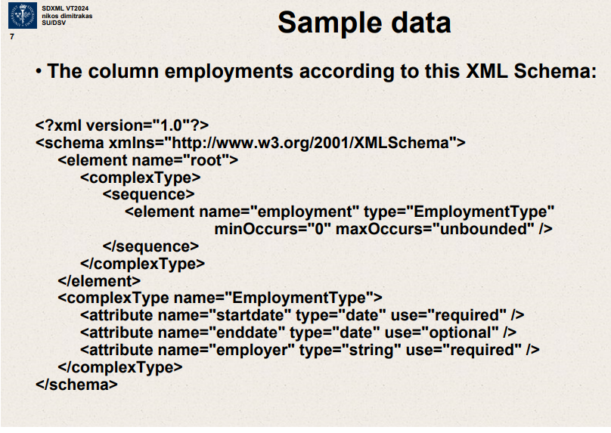

Employments according to this XML Schema

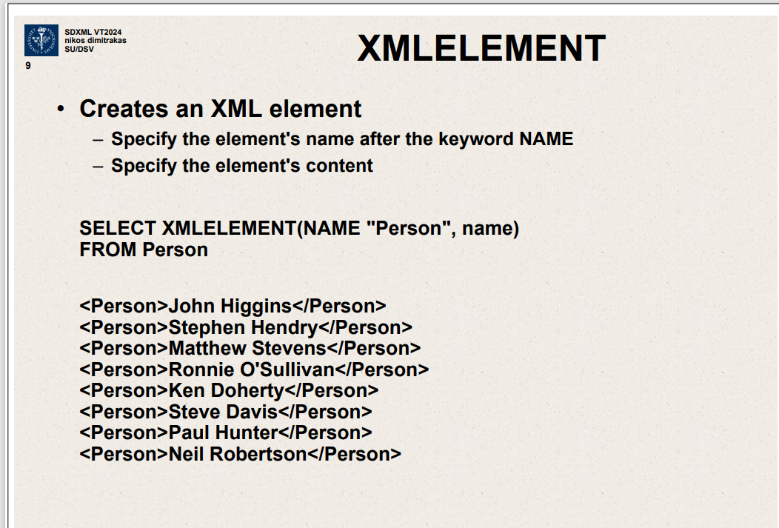

XMLELEMENT – creates an XML element

Specify element’s name after keyword NAME.

Specify element’s content.

SELECT XMLELEMENT( NAME “Person”,name)

FROM Person

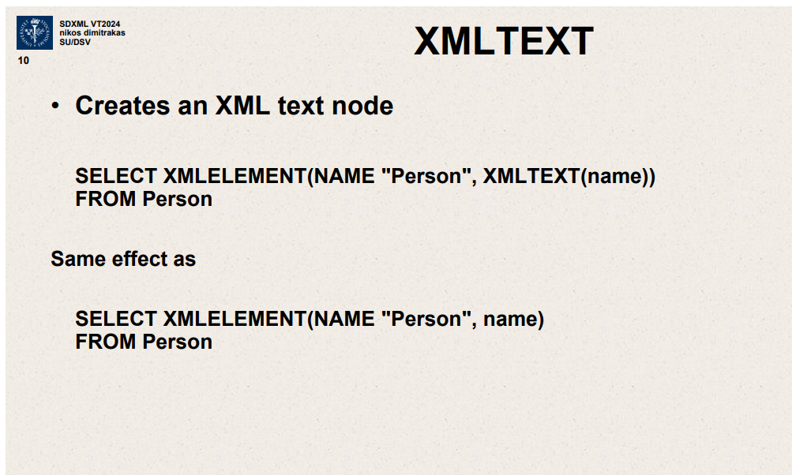

XMLTEXT – Creates an XML text node

SELECT XMLELEMENT(NAME “Person”,XMLTEXT(name))

FROM Person

XMLELEMENT

Creates an XML element

Specify element’s name after keyword NAME

Specify element’s content

SELECT XMLELEMENT(NAME “Person”, name)

FROM Person

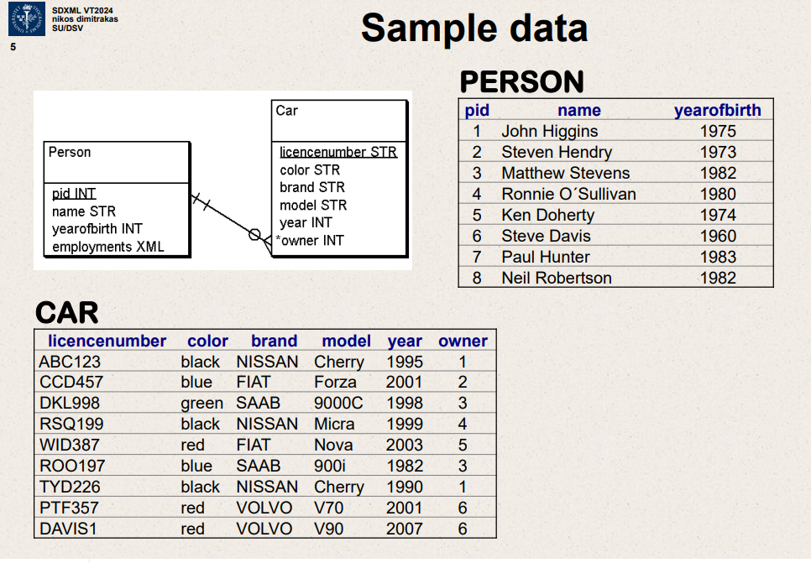

<Person>John Higgins</Person>

<Person>Stephen Hendry</Person

Name should be element’s content

XMLTEXT

SELECT XMLELEMENT (NAME “Person”, XMLTEXT(name))

FROM Person

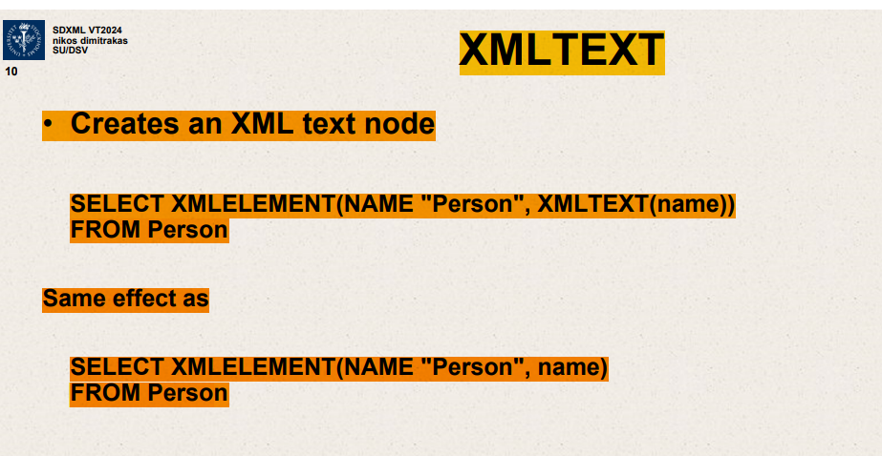

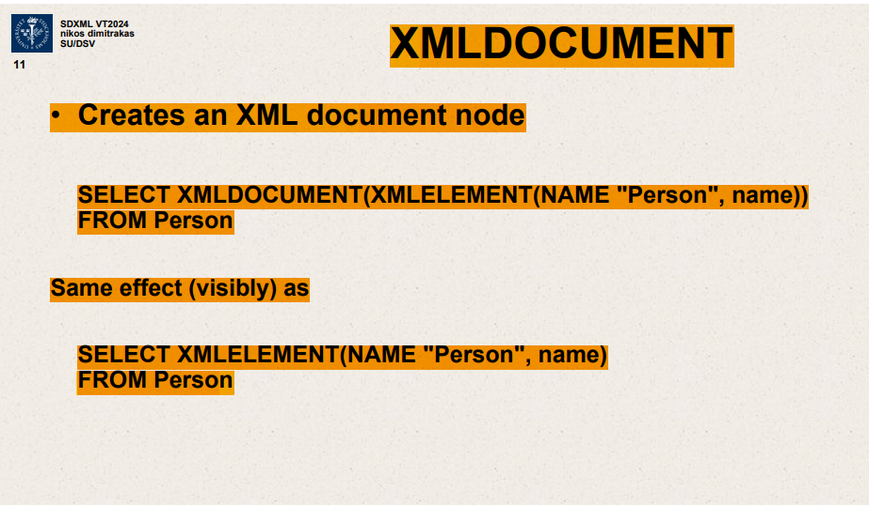

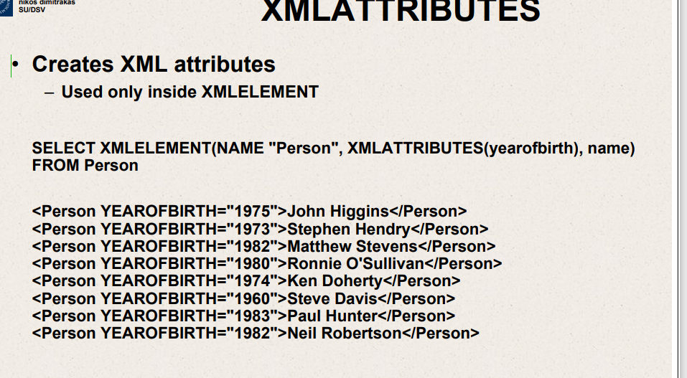

SELECT XMLELEMENT (NAME “Person”,XMLATTRIBUTES(yearofbirth),name)

FROM Person

Creates XML attributes ,used only inside XMLELEMENT

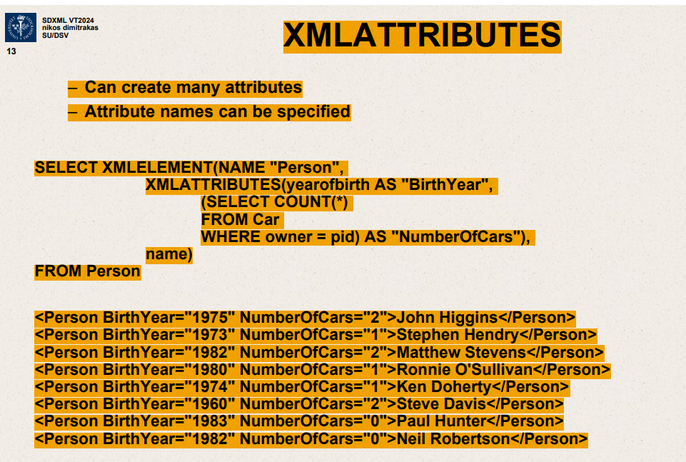

XMLATTRIBUTES – Can create many attributes

Attribute names can be specified

SELECT XMLELEMENT(NAME “Person”,

XMLATTRIBUTES*

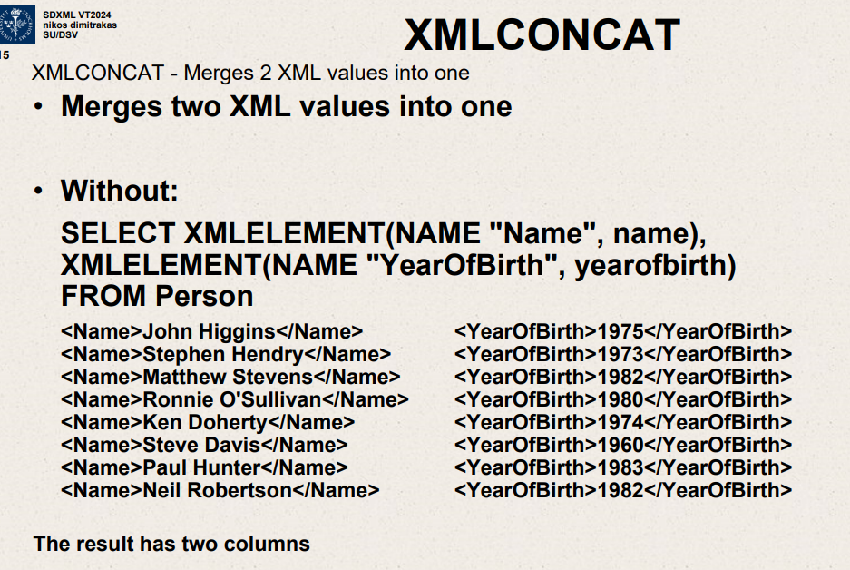

XMLCONCAT – merges 2 XML values into 1.

Without – the result has 2 columns

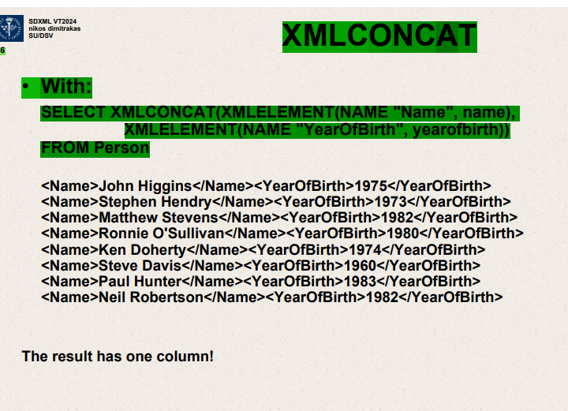

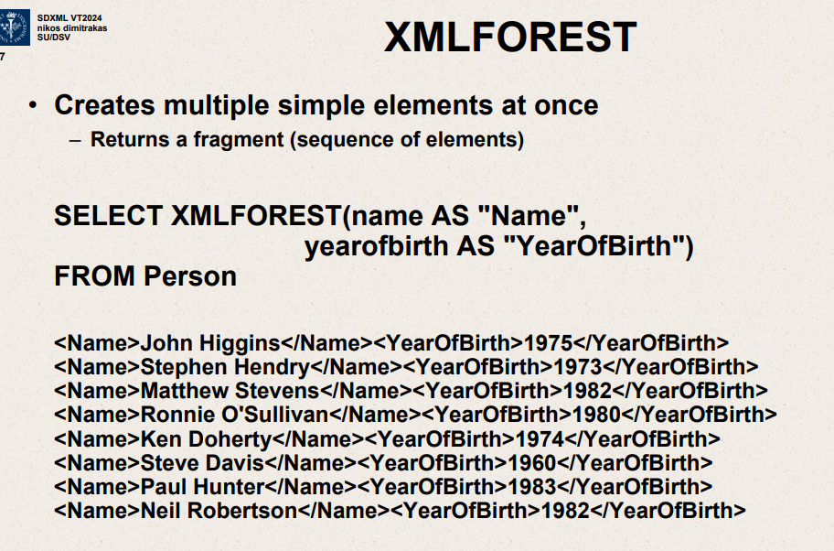

Creates multiple simple elements at once.

Returns fragment(sequence of elements)

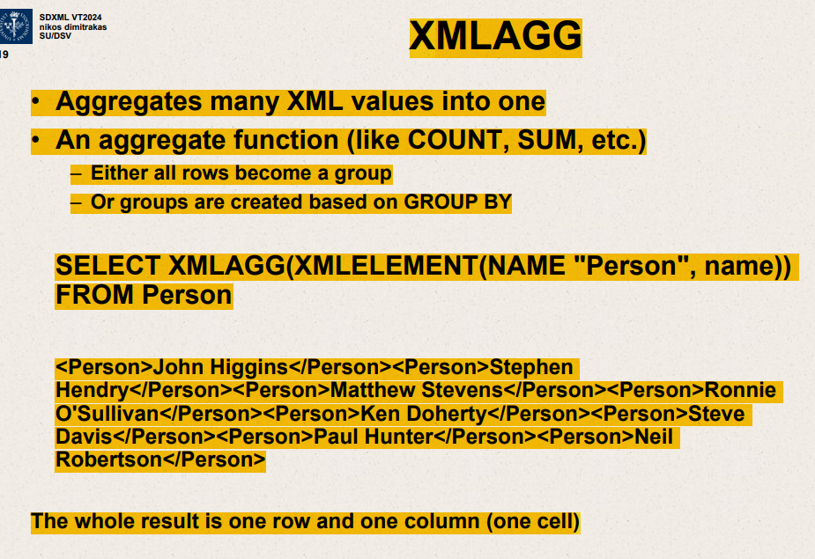

XMLAGG – Aggregates many XML values into 1.

Aggregate function like COUNT SUM etc.

Either all rows become a group

Or groups created based on GROUP BY

SELECT XMLAGG (XMLELEMENT(NAME “Person”,name))

FROM Person

XMLAGG with GROUP BY

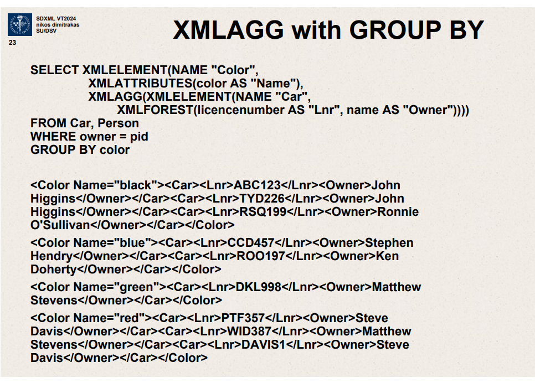

SELECT XMLELEMENT

SELECT XMLQUERY (‘for $a in (1,2,3) return element Number {$a}’)

FROM Person

WHERE pid=1

<Number>1</Number> <Number>2</Number>

XMLVALIDATE – Validates an XML value according to a schema

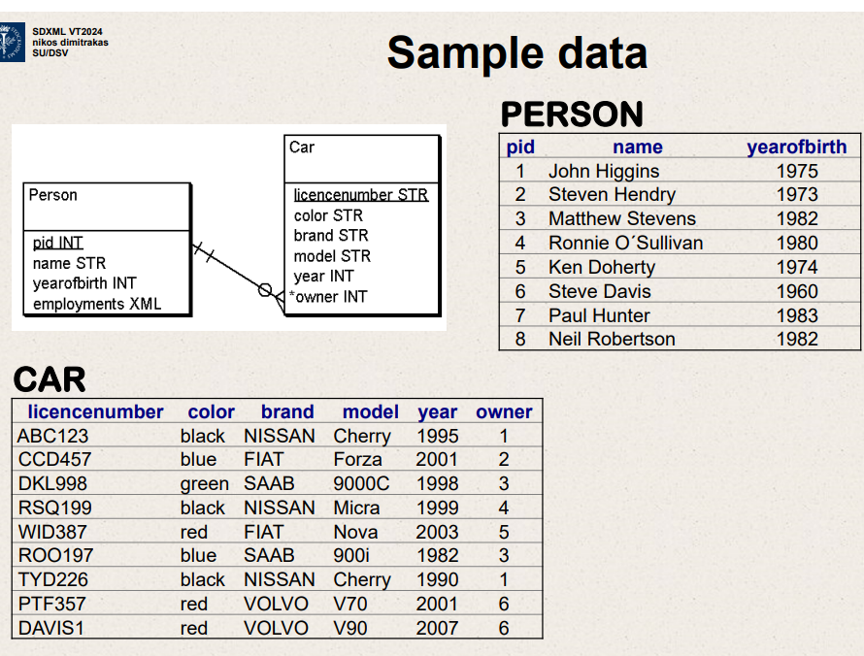

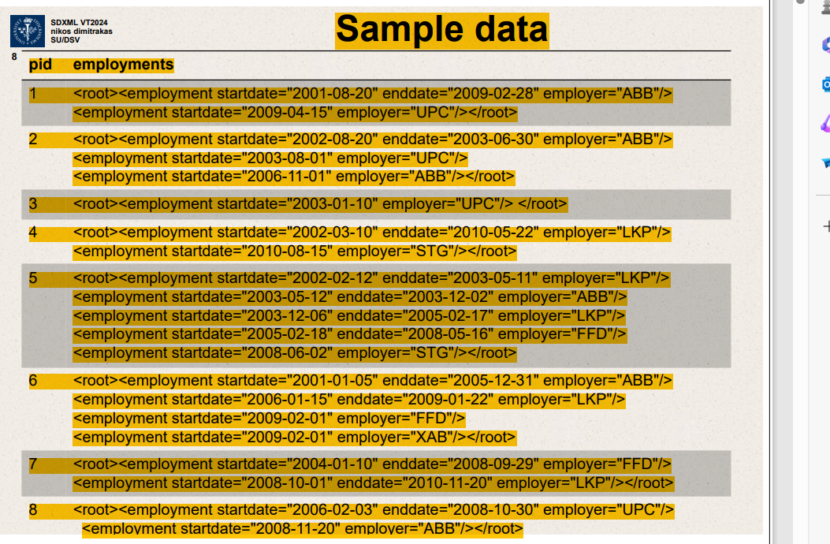

Support for xml in relational databases according to SQL:2003,SQL:2006,SQL:2008,SQL:2011.

SQL/XML – part of SQL standard

SQLX – group behind SQL/XML

SQLXML – Microsoft addition to SQL for XML

XML data type

Composition of XML (XML as result of SQL select)

Support for execution of Xquery

Support interoperability between Xquery and SQL

XML data type – store XML not serialized version

According to Xquery model

Every cell is XML document.

Support for validation.

